DEEPAK KUMAR CHAUDHARY
12010440
IIT Bhilai

- Create multiple accounts in the meta mask and perform the balance transfer between the various accounts.
Ans- STEP:-
- Firstly open metamask.io & create account 1,2,3…
- Click open(), enter the address, and then take the test ether into account.
- Go to A/C 1 Menu click on Send option. click option “transfer “ between my account .
- After that gas fee are add and click on “Confirm”
- Finally balance transfer from one account to another.

- Write a solidity program to set variables and get variables.

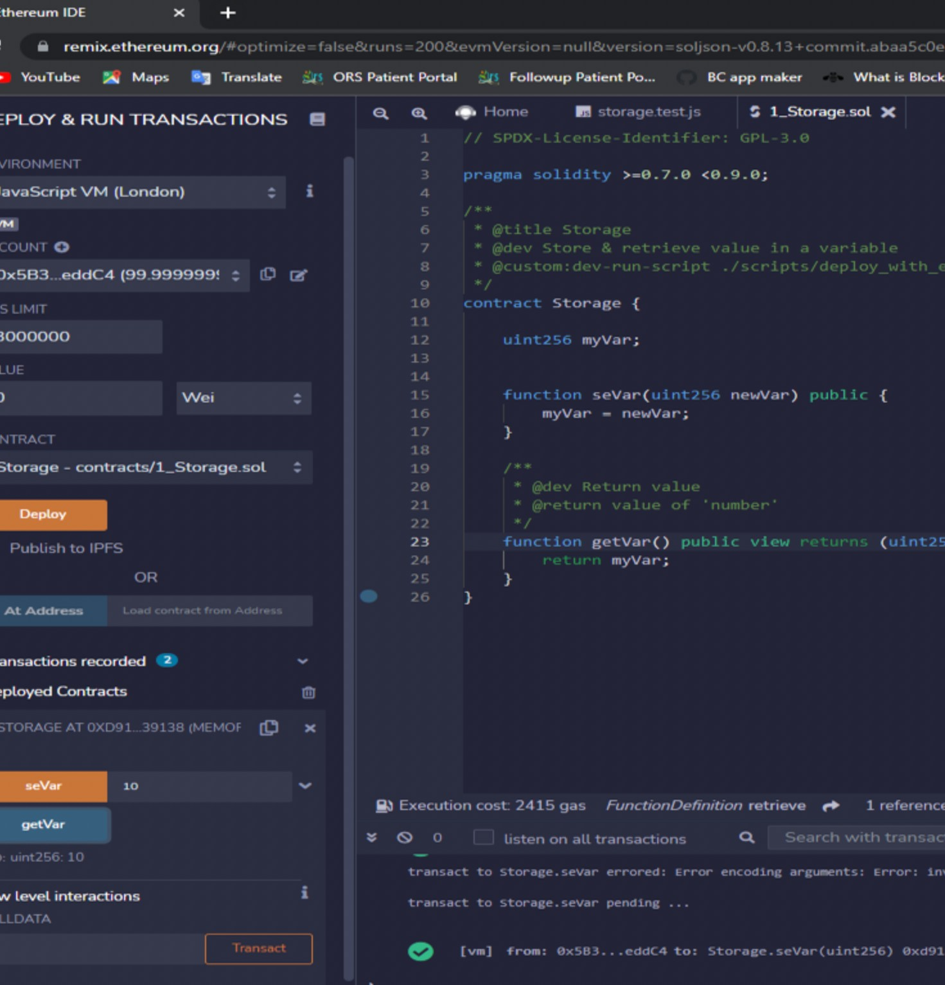

Caption

- Write a solidity program to perform push and pop operations on the dynamic array.

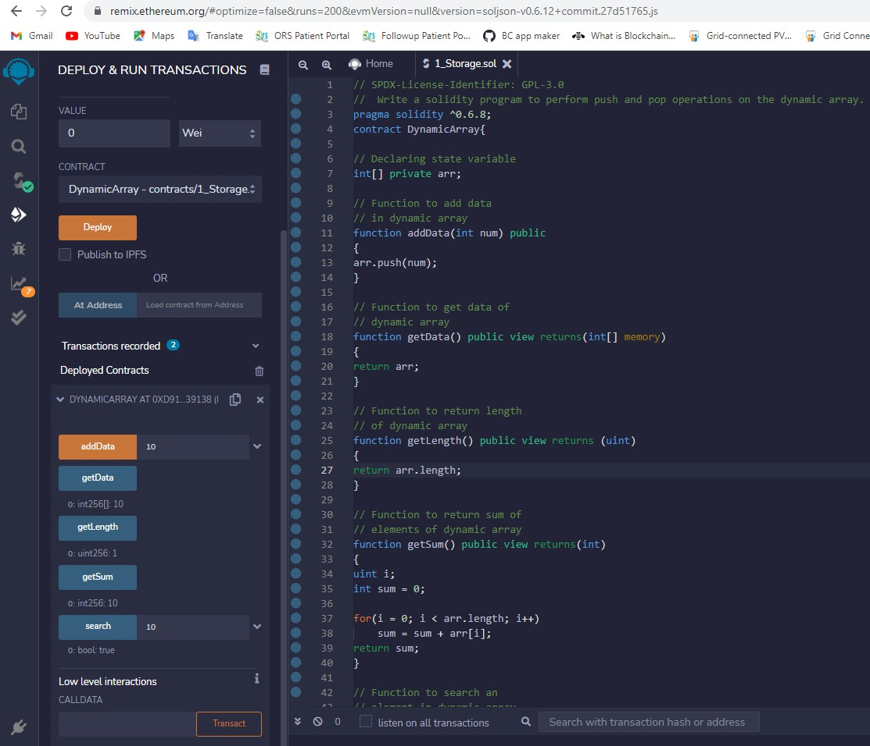

- write a solidity program to set address with a mapping variable
Ans- Code is written bellow. pragma solidity ^0.7.0; contract LedgerBalance {
mapping(address => uint) public balances; function updateBalance(uint newBalance) public { balances[msg.sender] = newBalance;
}
}
contract Updater {
function updateBalance() public returns (uint) { LedgerBalance ledgerBalance = new LedgerBalance();
ledgerBalance.updateBalance(10);
return ledgerBalance.balances(address(this));
}
}
- Write a solidity program to get the factorial of a number.
Ans-
pragma solidity ^0.4.19;

contract Factorial {
function fact(uint x) returns (uint y) { if (x == 0) {
return 1;
}
else {
return x*fact(x-1);
}
}
}

- Write a solidity program to store information about a student (name, roll no., institute, Age) using a structure.
Ans-

- Write a smart contract using a solidity program to perform the balance transfer from the contract to other accounts.
Ans-
// SPDX-License-Identifier: MIT
pragma solidity ^0.7.0;

contract CommunityChest {
function deposit(uint256 amount) payable public { require(msg.value == amount);
// nothing else to do!
}

function getBalance() public view returns (uint256) { return address(this).balance;
}
}

- Write a smart contract using a solidity program to perform balance transfer with mapping and make sure only the owner can transfer the balance from the contract to other accounts
Ans- // SPDX-License-Identifier: MIT
pragma solidity ^0.6.8;

// Creating a contract

contract MyContract
{
// Private state variable address private owner;

// Defining a constructor constructor() public{
owner=msg.sender;

// Function to get
// address of owner function getOwner(
) public view returns (address) {
return owner;

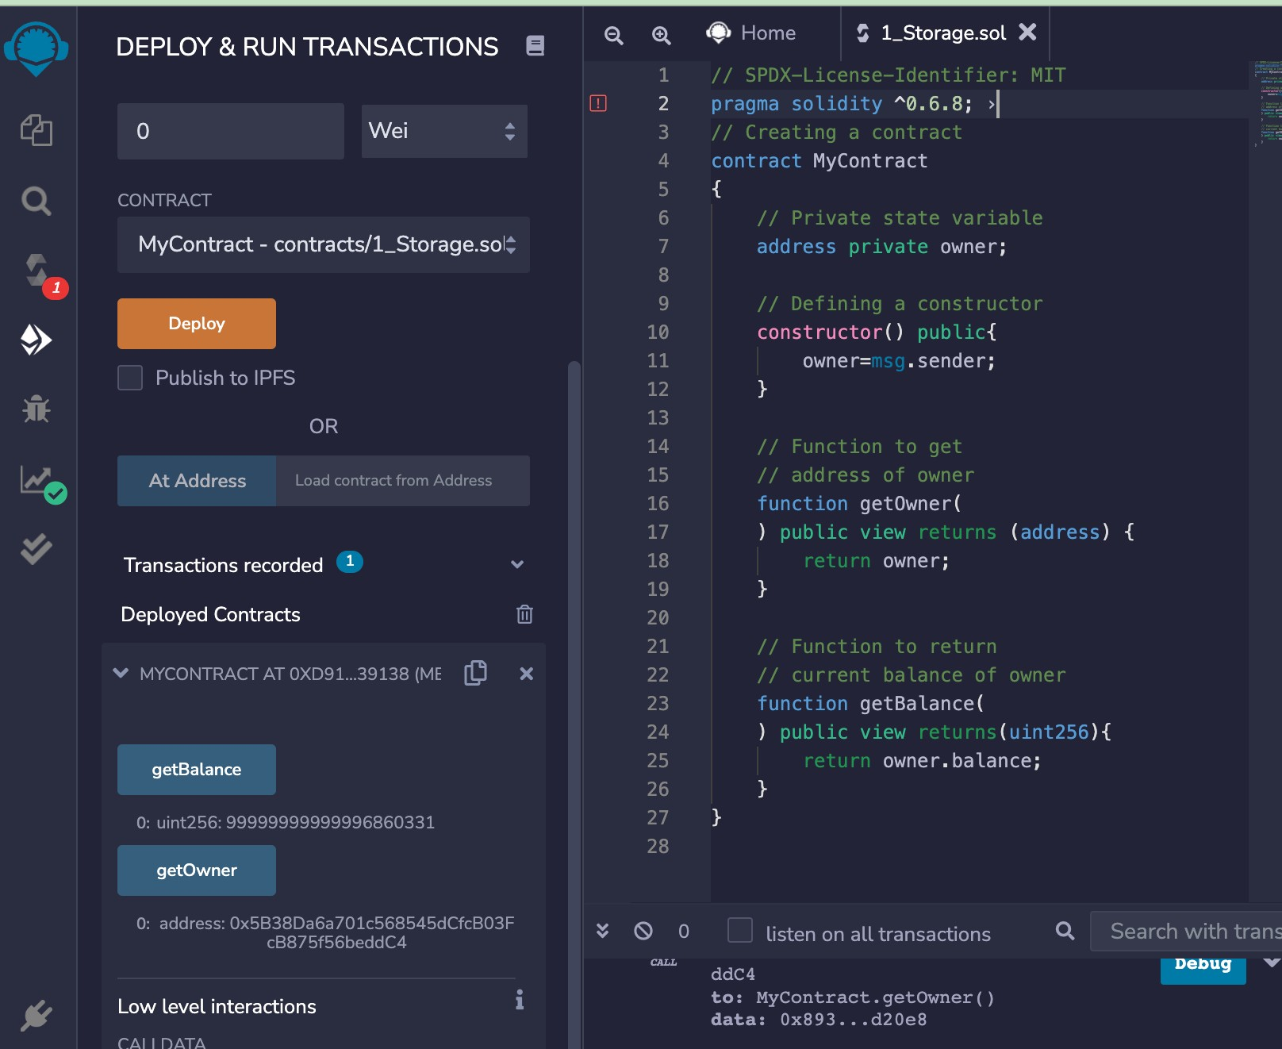

}

// Function to return
// current balance of owner function getBalance(
) public view returns(uint256){ return owner.balance;
}

- Write a solidity program to perform the exception handling and describe the details with screenshots.
Ans -
pragma solidity ^0.5.0;

contract Vendor { address public seller; modifier onlySeller() {
require(
msg.sender == seller, "Only seller can call this."
);
_;
}

function sell(uint amount) public payable onlySeller { if (amount > msg.value / 2 ether)
revert("Not enough Ether provided.");
// Perform the sell operation.
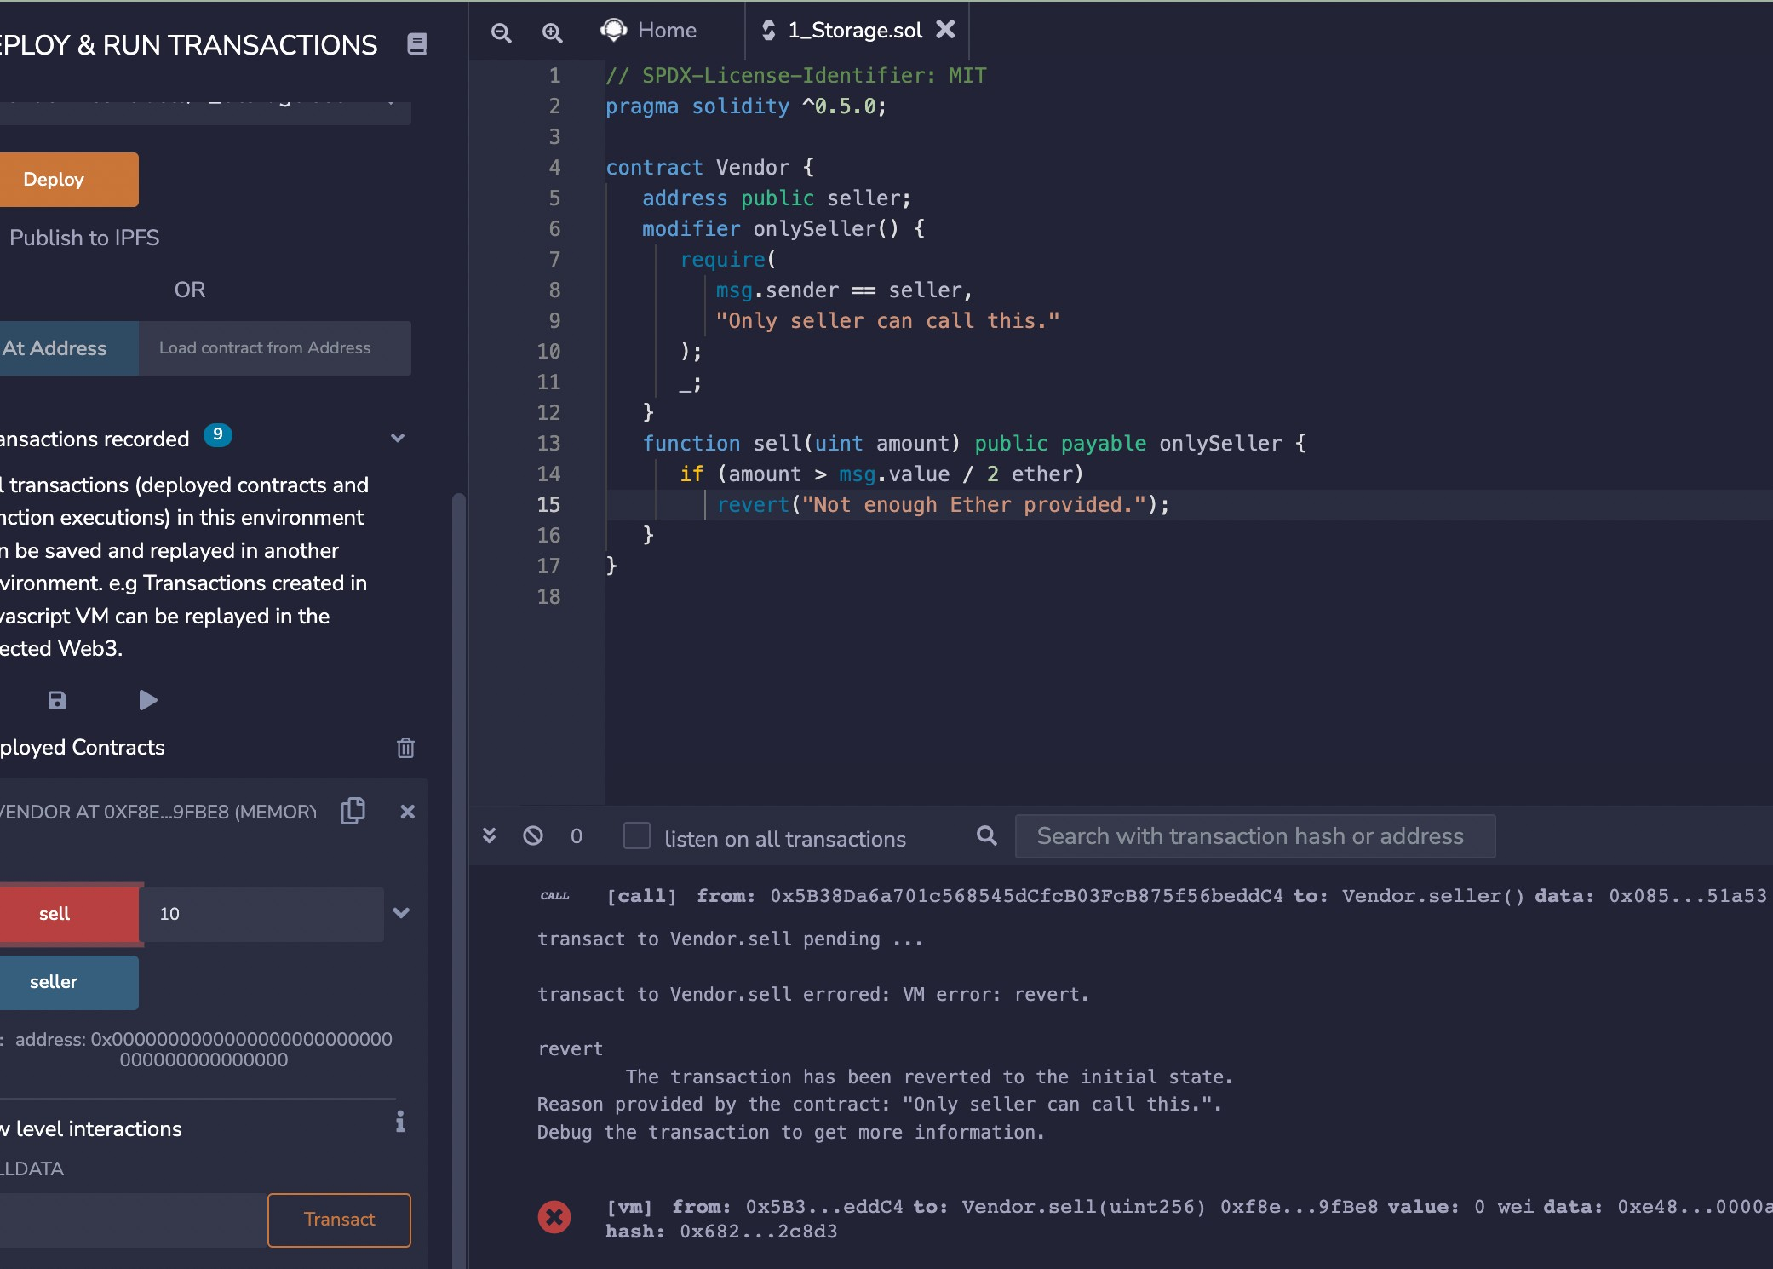
CDACAssignment Solution Blockchain Technology 12010440,IITBHILAI

Caption

}

- Connect the following tool with their mixed environment, perform balance transfer between the accounts with the smart contract and share the screenshots.
  - Ganache
  - Meta mask
Ans- firstly change the environment to “injected web3” and deploy the sol code. And after we get confirmation from meta mask shown in figure below.

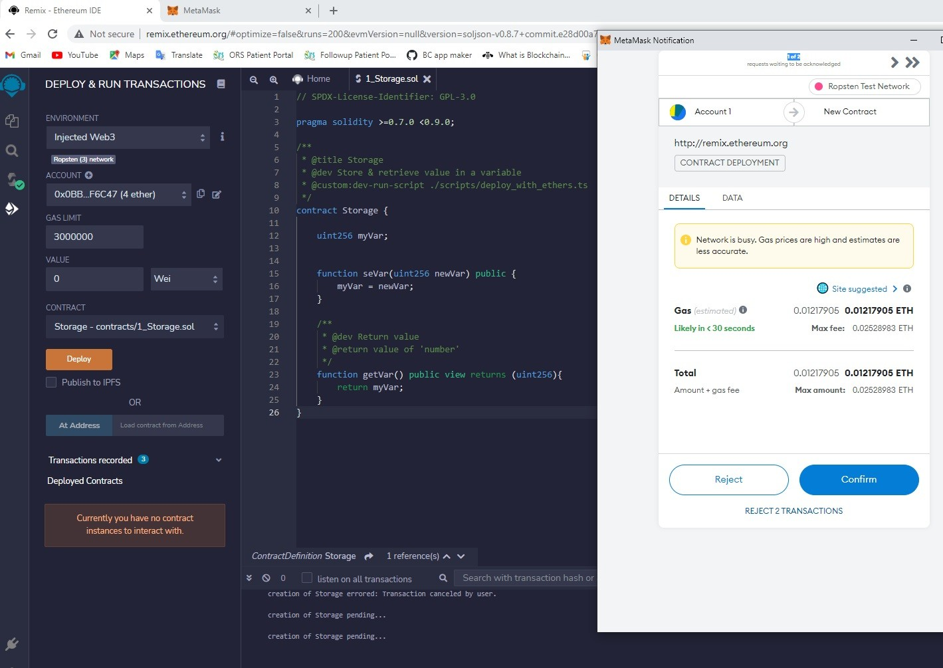

-for connecting ganache, we change the environment to “web3 provider”, finally ganache is connected and we can see the transaction on Block wise shown in screenshot below.

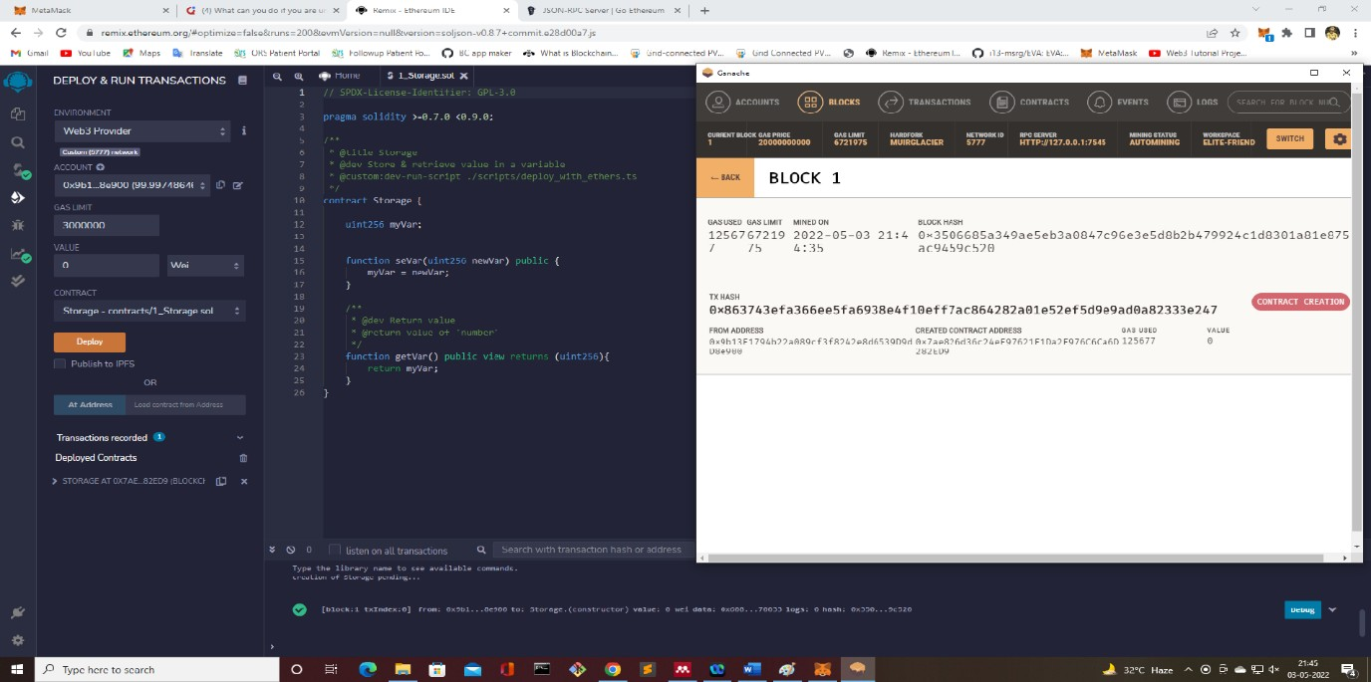

***************END**************

